FINAL DRAFT

ExxonMobil Technology and Engineering

**Geohazard Management Program**

**Appendix B:**

**Introduction to Geohazard Threats**

**Appendix Support Material**

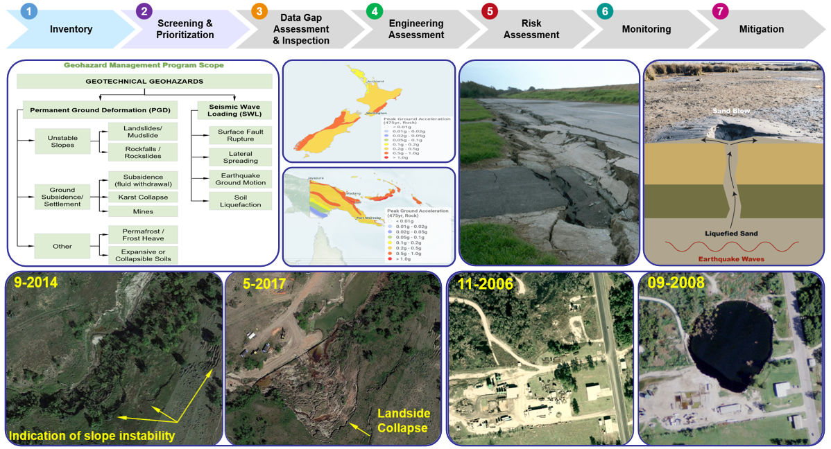Version 1 | March 2025

Revision Record

|  |  |  |  |
| --- | --- | --- | --- |
| Version No. | Date Issued | Reviewed By | Description |
| 0 | 11.2024 | EMPS  Roberto Landazuri  Steven Bevers | Initial release |
| 1.0 | 03.2025 | EMTech  Svetlana Shafrova  Patrick Lee | Enhanced for Global XOM use. Updated Susceptibility Hazards Maps to the latest releases available. Updated references/links for publicly available datasets, dashboards, monitoring portals. Added additional information for Germany, Indonesia, PNG, and Guyana as applicable. |
|  |  |  |  |
|  |  |  |  |

Contents

Contents iii

Introduction 1

1 GMP Workflow 2

2 Landslides 3

2.1 Unstable Slopes 3

2.2 Landslide Triggers 6

2.3 Effect of Landslides on Pipelines 7

3 Ground Subsidence/ Settlement 11

3.1 Subsidence Triggers 12

3.2 Effect of Subsidence on Pipelines 17

3.3 Subsidence Studies 17

4 Expansive and Collapsible Soils 18

5 Surface Fault Rupture 19

6 Earthquake Ground Motion 21

7 Soil Liquefaction 28

8 Lateral Spreading 29

9 Frost Heave and Thaw 30

Acronyms and Abbreviations 31

External References 32

Tables

Table 2‑1. Types of Slope Failures 4

Table 3‑1. Subsidence Trigger Factors 12

Table 6‑1. Earthquake databases and relevant seismic products 26

Table 6‑2. Earthquake Magnitude/Intensity Comparison 27

Figures

Figure 1‑1. General Geohazard Management Program Workflow (Stages 1 – 7) 2

Figure 2‑1. A Rotational Slide (a Type of Landslide) 3

Figure 2‑2. Landslide on the Bank of the Mackenzie River Caused by Erosion at the Toe of the Slope 6

Figure 2‑3. Principal Modes of Soil-Pipeline Interaction at Landslides 7

Figure 2‑4. Examples of Geometric Configurations between the Pipeline and Landslide 8

Figure 2‑5. U.S. Landslide Inventory and Susceptibility 8

Figure 2‑6. Global Landslide Hazard (Qualitative Map) 9

Figure 2‑7. Landslide Hazard Map for Australia, New Zealand, PNG, Indonesia 10

Figure 2‑8. Landslide Susceptibility Map for Canada 10

Figure 3‑1. Types of Ground Subsidence 13

Figure 3‑2. Cavity Formation Caused by Salt Dissolution due to Water Intrusion 13

Figure 3‑3. Sinkholes Examples at Wink and Daisetta, TX 14

Figure 3‑4. Global Subsidence Susceptibility Map 15

Figure 3‑5. US Subsidence Susceptibility Map 16

Figure 3‑6. U.S. Karst Formations Map 16

Figure 5‑1. Principal Modes of Soil-Pipeline Interaction at Fault Crossings 19

Figure 5‑2. U.S. Quaternary Faults Map 20

Figure 5‑3. Seismogenic faults - European Fault-Source Model 2020 20

Figure 6‑1. U.S. Seismic Hazard Maps 21

Figure 6‑2. European Seismic Hazard Map 22

Figure 6‑3. Germany Seismic Hazard Map 22

Figure 6‑4. UK Seismic Hazard Map 22

Figure 6‑5. Canada Seismic Hazard Map 23

Figure 6‑6. Australia Seismic Hazard Map 23

Figure 6‑7. New Zealand Seismic Hazard Map 24

Figure 6‑8. Indonesia Seismic Hazard Map 25

Figure 6‑9. New Zealand Seismic Hazard Map 25

Figure 6‑10. PNG Seismic Hazard Map 25

Figure 6‑11. Guyana Seismic Hazard Map 25

Figure 7‑1. Liquefaction Process and Impact on Buried Pipelines 28

Figure 8‑1. Lateral Spreading 29

Figure 9‑1. Schematics of Frost Heave and Thaw Settlement for Buried Pipeline 30

Introduction

Geohazards that may affect pipelines are a specific subset of natural hazards. In the broadest sense, the Federal Emergency Management Agency (FEMA) defines natural hazards as: “natural events [earth processes] that threaten lives, property, and other assets”. Examples include hurricanes, earthquakes, landslides, coastal & riverine flooding, tsunamis, tornadoes, etc. *[16]*.

The term “geohazards” is used to describe the hazards that may derive from any potential gravity-related geological and geotechnical problem or failure, such as slope instabilities, landslides, and ground settlements. The processes that induce geohazards could be both naturally-occurring (such as erosion, bedrock dissolution), and caused or triggered by human activity (aquifer system compaction, changes in drainage). Seismic events may also aggravate gravity-related geohazards (by triggering slope instabilities) and/or may cause additional geohazards to the pipeline (such as the rupture of active faults or soil liquefaction phenomena).

Geohazards for buried steel pipelines can be classified into two main categories such as “Geotechnical” and “Hydrotechnical”. The Geohazard Management Program (GMP) addresses the geotechnical hazards such as landslides, subsidence, and faulting, and other similar types of hazards that result in permanent ground displacement (PGD), while hydrotechnical hazards from the action of water including the riverbank slope stability concerns are stewarded by the Water Crossing Program (WCP). For details about hydrotechnical hazards types, evaluation, and assessment techniques, refer to the *Water Crossing Program (WCP)* [*Manual*](https://teamwork4.exxonmobil.com/sites/GlobalWCP/Shared%20Documents/WCP%20Toolkit/WCP%20%20Manuals%20and%20Guidelines/WCP%20Manual).

The applied PGD causes pipeline to: (1) Deform axially (axial strain), and/or (2) Bend (bending strain). The principal limit states or failure modes for corrosion-free continuous pipelines (e.g., steel pipe with welded joints) are:

* Rupture due to axial tension and/or bending, and
* Local buckling due to axial compression and/or bending.

The typical geotechnical hazards affecting the pipelines are briefly discussed is sections below.

# GMP Workflow

The GMP workflow (*Figure 1‑1*) is designed to (1) identify and manage geotechnical threats; (2) identify, monitor, and manage changes over time; and (3) comply with regulatory and industry standards requirements and recommendations as well as align with best practices.

Figure 1‑1. General Geohazard Management Program Workflow (Stages 1 – 7)



The Geohazard Threats described herein will be used to develop geohazard inventory as part of GMP *Stage 1 Inventory*and to perform screening and prioritization discussions during GMP *Stage 2* as applicable.

GMP Inventory development is a hazard identification stage which is fundamental basis for understanding the geohazard conditions that could potentially impact the integrity of pipelines. The GMP inventory (*Stage 1)* applies to both future (under design/construction) and operating pipeline assets.

# Landslides

## Unstable Slopes

The term “Landslide” is generally used to describe the downslope movement of soil, rock, and organic materials under the effects of gravity or seismically induced (*Figure 2‑1*). Due to the long, linear nature of pipeline corridors, they often cross areas that are highly susceptible to landslides.

A landslide occurs when the downslope component of forces (i.e. driving forces) acting on the slope exceeds the resistance of the materials underlying the slope (i.e. resisting forces). Driving forces can be increased by changes to slope geometry (e.g., erosion of the toe) or by increased loading on the slope (e.g., fill placement on the slope). Resisting forces can be reduced by weathering of the material along slip surfaces underlying the slope and by increased/raised groundwater/pore water pressure levels in the slope. The landslide mass may be composed of soil, rock, or both (i.e., earth). The type of movement may comprise slides, spreads, flows, falls, and topples. *Table 2‑1* shows the types of slope failures.

Figure 2‑1. A Rotational Slide (a Type of Landslide)

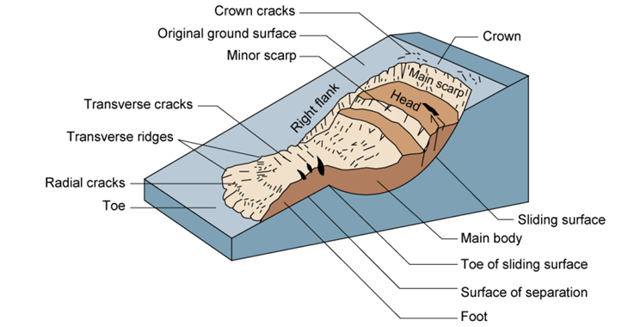

Source: Highland and Bobrowsky (2008), *[24]*.

Changes to the environment such as intense precipitation events, earthquakes, undercutting and erosion by streams, and/or activities of humans can initiate or trigger landslides. Landslides are often a function of hydrological conditions within the hill, rock slope, or bank, as increased saturation adversely affects slope stability. Landslides may occur in hillsides, rock slopes, or along the banks of waterways. Landslides in the banks of waterways may be impacted by riverine scour at the toe of the slope, as well.

Landslides may be shallow or they may be deep-seated. Those failures that tend to be shallow and non-eroding to the surrounding terrain pose little hazard to pipelines. Given that pipelines are typically buried to a minimum depth of 3 ft (~1 m), small, shallow surficial landslides present less of a threat to pipelines than larger deep-seated landslides. In many cases, pipelines can be buried (using conventional open cut excavation and backfilling) deeper than the depth of the unconsolidated soil mantle pre- sent on many hillsides that are prone to shallow landslide.

Table 2‑1. Types of Slope Failures

|  |  |  |
| --- | --- | --- |
| **Type** | **Description** | **Image** |
| **Slides** | Rotational slides: masses slide outwards and downwards on one or more concave-upward failure surfaces that impart a backward tilt to the slipping mass, which sinks at the rear and heaves at the toe |  |
| Translational slides: movements occur along planar failure surfaces that may run more-or less parallel to the slope |  |
| **Spreads** | Involve the fracturing and lateral extension of coherent rock or soil masses due to plastic flow or liquefaction of subjacent material |  |
| **Flows** | Slow to rapid movements of saturated or dry materials which advance by flowing like a viscous fluid, usually following an initial sliding movement |  |
| **Falls** | Masses are detached from steep slope/cliff along surfaces with little or no shear displacement (e.g. joints/fissures) and descend mostly through air by free fall, bouncing or rolling |  |
| **Topples** | Movements of rock, debris or earth masses by forward rotation about a pivot point |  |
| **Complex** | A complex slide involves one of the main types of movement followed by two or more of the other main types of movement |  |

Source: Highland and Bobrowsky (2008), *[24]* adopted from Varnes (1978), *[46]*.

A large portion of commonly- occurring landslides (falls and slides in soil and rock and debris flows) that tend to be triggered in great numbers in seismic or extreme precipitation events are negligible threats to pipelines. Exceptions are cases in which:

* Large rock fragments from rock falls and slides are capable of penetrating or transmitting damaging stresses to pipeline- burial depths,
* Established rock-fall and rock-slide chutes erode to such depths, or
* Debris flows commonly scour deep enough to affect the pipeline integrity. The primary threat to pipelines from slope failures arise from the movement of landslides whose failure surface or surfaces are several feet or greater in depth. Landslides with rotational and/or translational movement components pose potential threats to pipeline integrity from displacements large enough to damage or rupture the pipe.

Landslides may occur extremely rapidly (e.g., seconds, minutes, or hours) and may be episodic, or as slow, on-going processes occurring over months, years, and centuries. The stability of a slope is directly related to the following factors:

* Slope geometry e.g. inclination
* Material properties of the soil and rock underlaying the slope e.g. soil/rock strength
* Surface and groundwater/pore water conditions within the slope and along rupture surfaces
* State of stress and stress history of the slope.

## Landslide Triggers

Sloping ground is subjected to driving gravitational forces. The ground will remain static as long as the driving forces remain smaller than the resisting forces, which derive from the shear strength of the earth mass. A landslide is triggered when the driving forces become larger than the resisting forces, which occurs when the driving forces increase, or the resisting forces decrease.

The following are examples of an increase in the driving forces:

* The addition of earth at the crest of the slope caused by anthropogenic fill or natural deposition
* Overall steepening of the slope
* Increase of hydrostatic pressures & seepage forces caused by intense precipitation, rapid snowmelt, and poor drainage
* Dynamic forces caused by seismically induced ground shaking or volcanic eruptions.

A decrease in the resisting forces is typically caused by the following:

* Removal of earth at the toe of the slope caused by anthropogenic excavation or natural stream erosion (*Figure 2‑2*)
* Reduction in the rock/soil strength due to mechanical weathering or chemical weathering
* Reduction of the strength of partially saturated soils due to saturation following intense rainfall combined with poor drainage
* Reduction of the strength of saturated soils caused by seismically induced ground motions (this is a phenomenon commonly described as *soil liquefaction*)
* Reduction of the strength of soils due to thawing of permafrost or the effects of freeze and thaw cycles
* Reduction of the strength of soils or rock caused by an increase in the elevation of the groundwater piezometric surface.

Figure 2‑2. Landslide on the Bank of the Mackenzie River Caused by Erosion at the Toe of the Slope

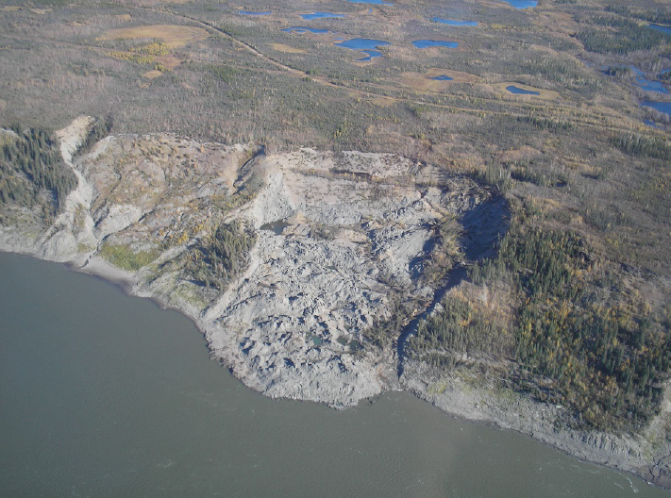

Source: PRCI (2018), *[33]*.

## Effect of Landslides on Pipelines

The severity of hazard to a pipeline posed by a landslide will depend on the location of the pipeline with respect to the unstable area, amount of PGD, relative direction of movement, soil type, strength and density of the earth materials, and the design details for the pipeline, such as pipe diameter, wall thickness, type of weld, and weld stress- strain characteristics. *Figure 2‑3* (below) shows the locations of pipeline bending, tension, and compression when a pipeline is subjected to ground displacement caused by landslides.

Figure 2‑3. Principal Modes of Soil-Pipeline Interaction at Landslides

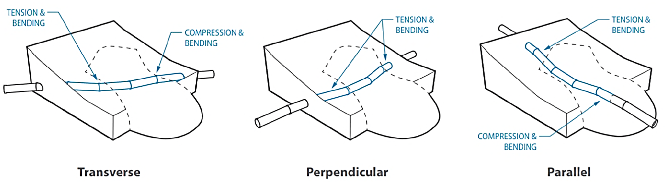

Source: O’Rourke (1998), *[32]*.

*Figure 2‑4* illustrates five configurations between a hypothetical pipeline and the extent of a rotational slide. Referring to this figure, a lower hazard can be assigned to the case in which a pipeline is next to the unstable area (A), but higher hazard develops when the pipeline intersects the landslide. The highest hazard is likely to exist when the pipeline is aligned approximately perpendicular to the direction of slope movement (C, D, E), as PGDs impose bending and shear stresses on the pipeline, in contrast to axial stresses that develop when the pipeline is aligned parallel to the direction of movement (B). Bending stresses may be larger when a pipeline intersects the toe of the slide (C) compared to the head of a slide (D), as lateral displacements have an upward and lateral component near the toe.

Figure 2‑4. Examples of Geometric Configurations between the Pipeline and Landslide

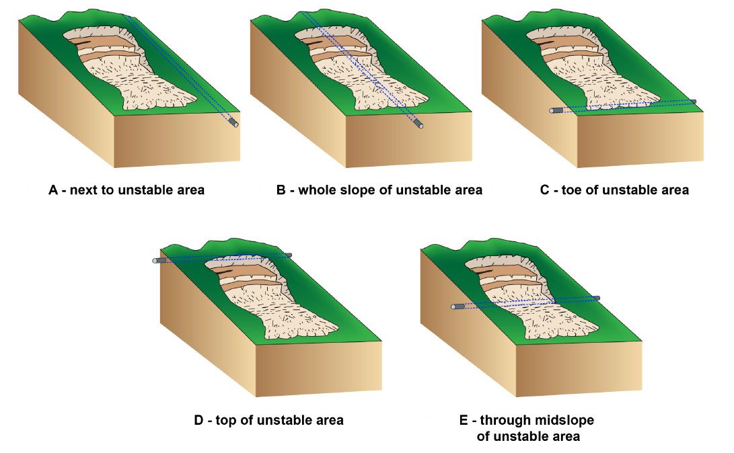

Source: PRCI (2018), *[33]*.

Various types of landslide maps are available for use. The United States Geological Survey (USGS) definitions of landslide inventory, susceptibility and hazard together with some examples are given below.

Landslide inventory maps show landslide locations and might show the dimensions and geographical extent of each landslide. The USGS map of U.S. Landslide Inventory is shown on *Figure 2‑5*.

Figure 2‑5. U.S. Landslide Inventory and Susceptibility

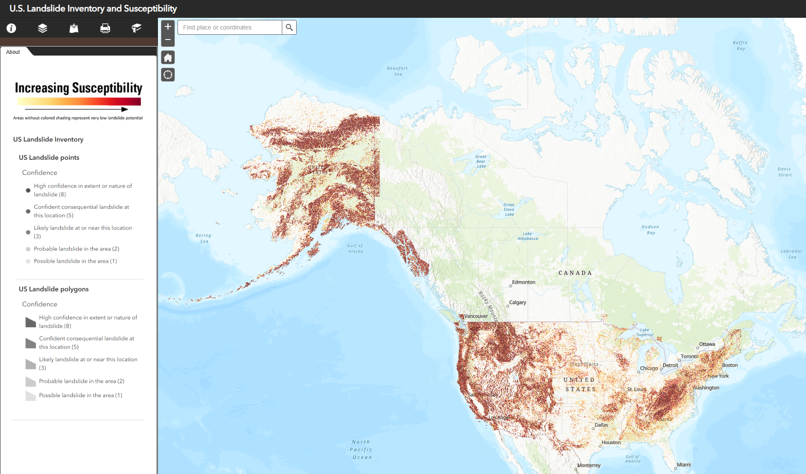

Source: USGS (2025), *[40]*.

Landslide hazard maps indicate the possibility of landslides occurring throughout a given area. An ideal landslide hazard map shows not only the chances that a landslide might form at a particular place, but also the chance that it might travel downslope a given distance.

Landslide susceptibility maps or “landslide potential map” describe the relative likelihood of future landsliding based solely on the intrinsic properties of a locale or site. Prior failure (from a landslide inventory), rock or soil strength, and steepness of slope are three of the more important site factors that determine susceptibility.

The examples of landslide hazard maps for the entire World and for Asia Pacific area a are given on *Figure 2‑6* and *Figure 2‑7*. An example of a landslide susceptibility map for Canada is given on *Figure 2‑8.*

Figure 2‑6. Global Landslide Hazard (Qualitative Map)

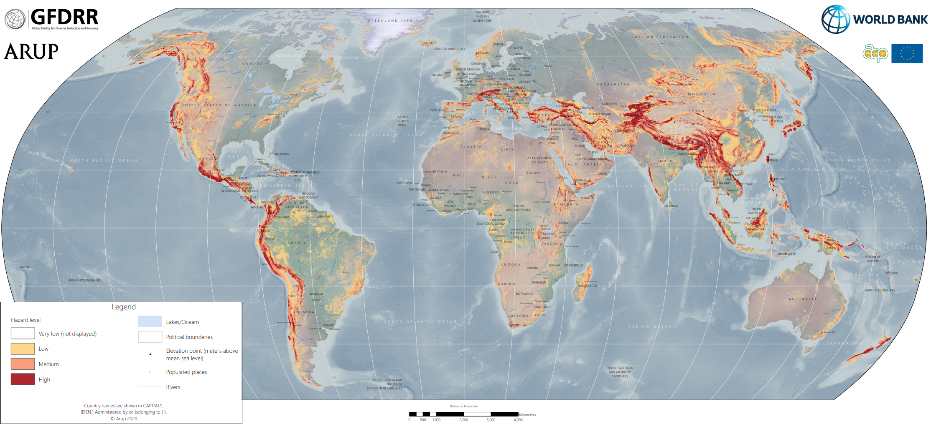

Source: ARUP (2020), *[2]*.

Figure 2‑7. Landslide Hazard Map for Australia, New Zealand, PNG, Indonesia

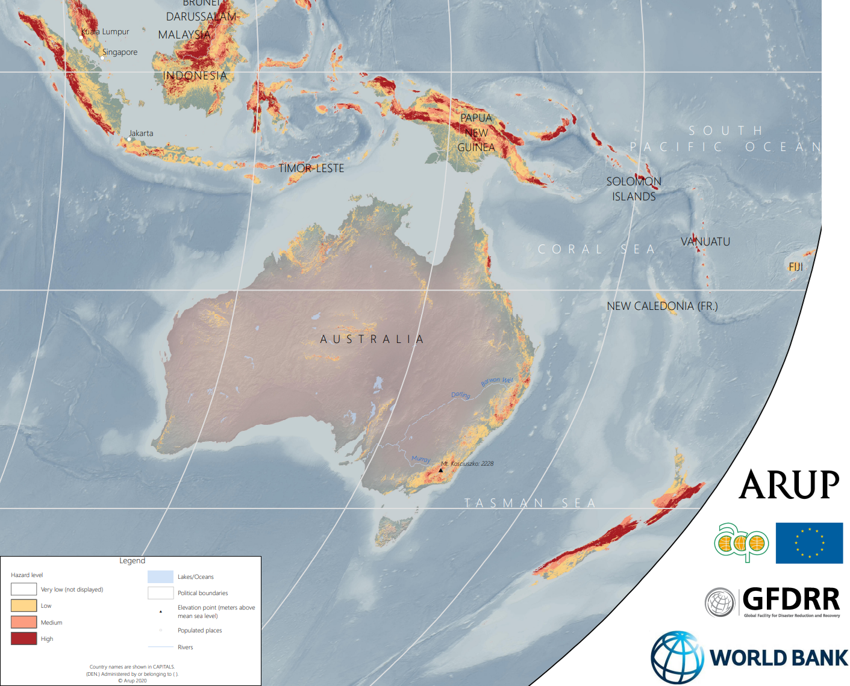

Source: ARUP (2020), *[2]*.

Figure 2‑8. Landslide Susceptibility Map for Canada

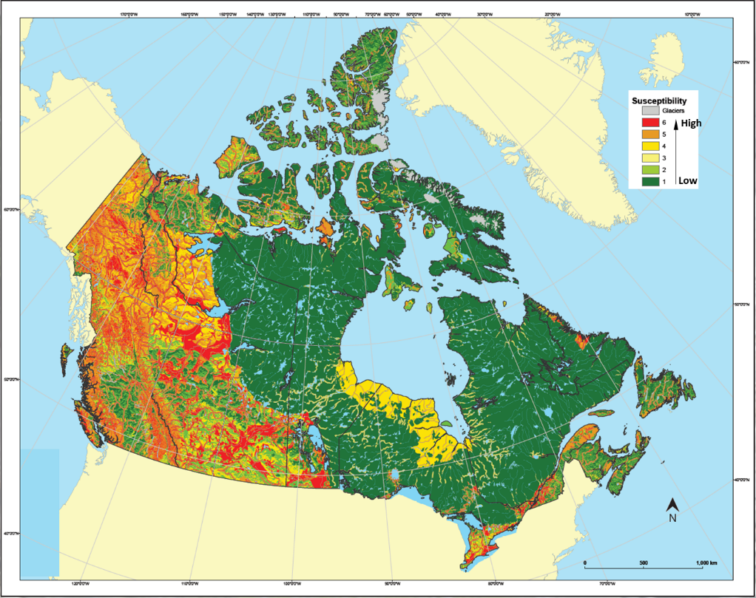

Source: Bobrowsky and Dominguez (2012), *[9]*.

# Ground Subsidence/ Settlement

Land subsidence is a gradual settling or sudden sinking of the Earth’s surface resulting from the subsurface movement of earth materials (rock and soil) *[34]*.

The primary subsidence hazards that could affect a pipeline system include both naturally occurring processes, and processes that are caused or triggered by human activity. The primary types of subsidence of the ground surface that could affect pipeline integrity systems include:

Naturally occurring processes:

* Subsurface dissolution of bedrock
* Thawing of permafrost
* Subsurface erosion.

Human-caused/triggered processes:

* Fluid withdrawal and aquifer system compaction
* Collapse of underground mine workings
* Drainage of organic soil.
* Hydrocompaction of soil; and
* Localized settlement of pipe trench and pipe construction backfill.

The USGS *[34]* recognizes that to identify future subsidence, it is important to detect:

* Areas that have subsided recently
* Areas that are actively subsiding
* Areas where activities (mining, for example) that encourage subsidence are occurring
* Areas that are similar in terms of topography, geomorphology, hydrology, and soil properties to areas that show evidence of past subsidence.

## Subsidence Triggers

The information below was adopted from PRCI (2018) *[33]*. Subsidence develops in response to gas or liquid being extracted from below the ground surface, as well as extraction or dissolution of solid matter. Factors that can cause or trigger subsidence are summarized in *Table 3‑1*:

Table 3‑1. Subsidence Trigger Factors

|  |  |
| --- | --- |
| **Factor** | **Root Causes** |
| **Mining** | Mining activities (i.e., removal of solid matter from the subsurface) produces a void that may collapse and cause downward movement of the ground surface |
| **Sinkhole** | These are spherical, ellipsoidal, or tubular shaped depressions that develop in karst or pseudo-karst areas. Sinkholes may develop either naturally in relatively soluble evaporate (salt and gypsum) deposits and carbonate (limestone and dolomite) rocks or anthropogenically through processes that accelerate the dissolution of these deposits. |
| **Subsurface Fluid Withdrawal** | Removing fluids (water, oil, gas) from the subsurface causes a pressure reduction in the fluid, which in turn causes an increase in the vertical stress applied to the structure of the fluid-bearing soils and rocks. This stress increase is accompanied by a reduction in volume that manifests itself at ground surface as downward vertical displacements. |
| **Permafrost Thawing** | Permafrost is the permanently frozen layer of earth present in cold regions. Climatic or anthropogenic causes, such as the heat released by the contents of the pipeline, can lead to increases in temperature that thaw the permafrost layer and cause volume reduction and subsequent downward vertical displacement of the ground surface. |

The types of ground subsidence with the mechanism of formation are schematically shown in *Figure 3‑1.*

The schematics of cavity formation by salt dissolution due to water intrusion is shown in ***Error! Reference source not found.****.* The examples of existing sinkholes at Wink and Daisetta, TX are shown in *Figure 3‑3.* The example of global subsidence susceptibility map is given in *Figure 3‑4*. The US Subsidence Susceptibility Map from USGS is shown in *Figure 3‑5*. The map of U.S. Karst formations from USGS is shown in *Figure 3‑6*.

|  |  |
| --- | --- |
| Figure 3‑1. Types of Ground Subsidence    Source: Wikipedia (2025a) *[47]*. |  |

|  |  |
| --- | --- |
| Figure 3‑2. Cavity Formation Caused by Salt Dissolution due to Water Intrusion | |
| Source: USGS (1999) *[34]*. | Source: J-W. Kim et al. (2016), *[25]* |

Figure 3‑3. Sinkholes Examples at Wink and Daisetta, TX

|  |  |
| --- | --- |
| **Before**  **1-1996**  **Before** | **After**  **After**  **Wink, May 21, 2002**  **03-2005** |
| **11-2006** | **09-2008**  **Daisetta, May 7, 2008** |

Source: Google Earth, Accessed March 2025.

Figure 3‑4. Global Subsidence Susceptibility Map

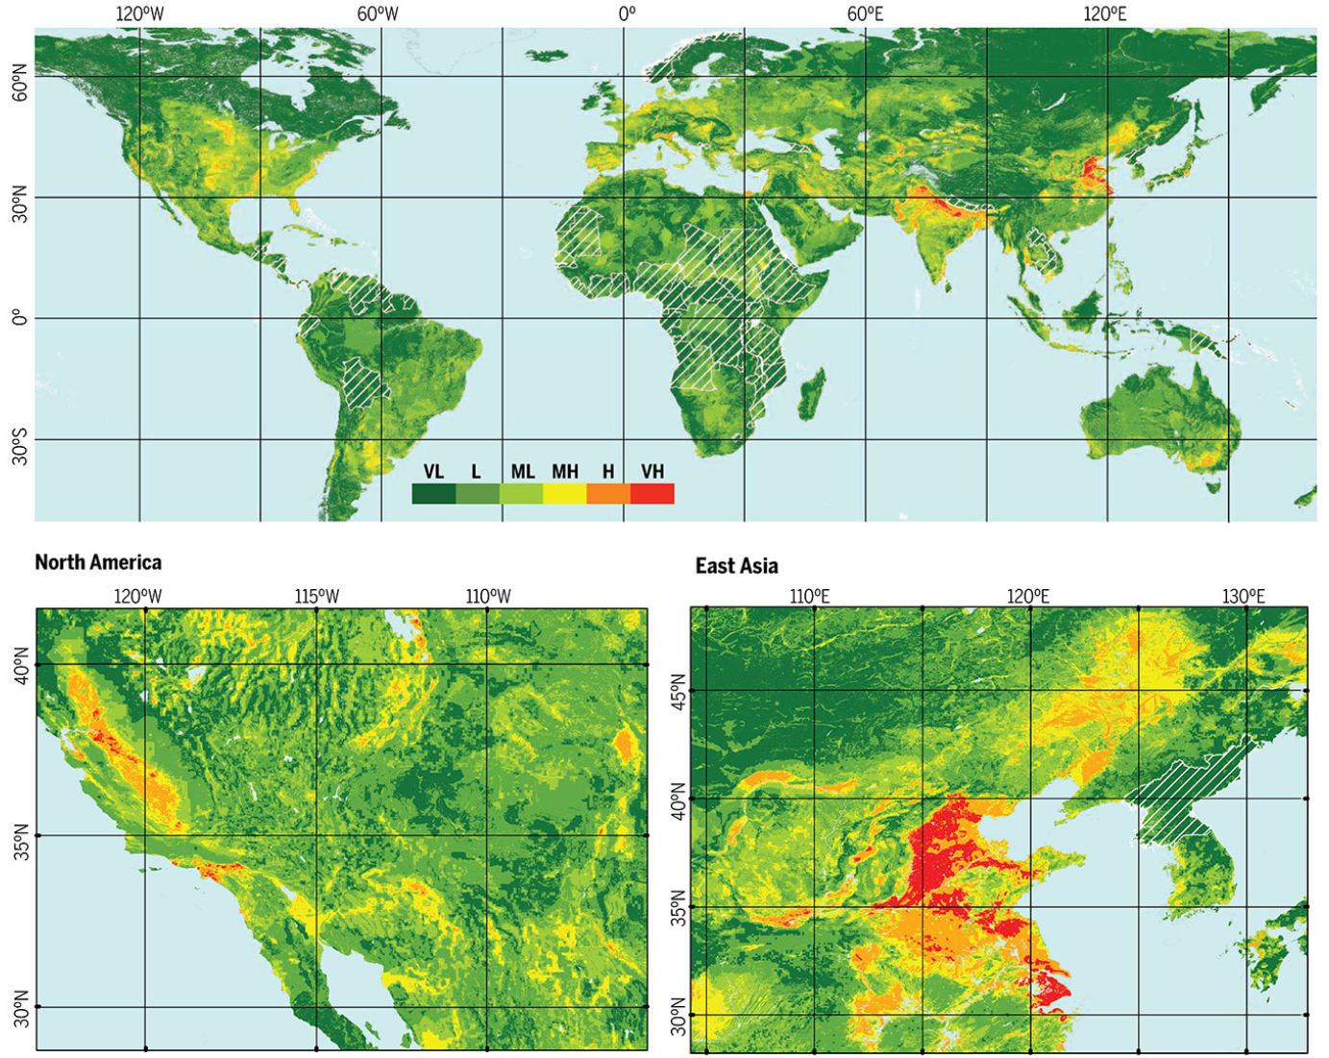

*Probability of subsidence susceptibility calculated from 0 to 1 for every 30’’ resolution pixel, 1 km x 1 km at the Equator. The color scale indicates the probability intervals classified from very low (VL) to very high (VH), for every 30’’ resolution pixel (1 km x 1 km at the Equator).*

Source: Herrera-García et al. (2021), *[23]*.

Figure 3‑5. US Subsidence Susceptibility Map

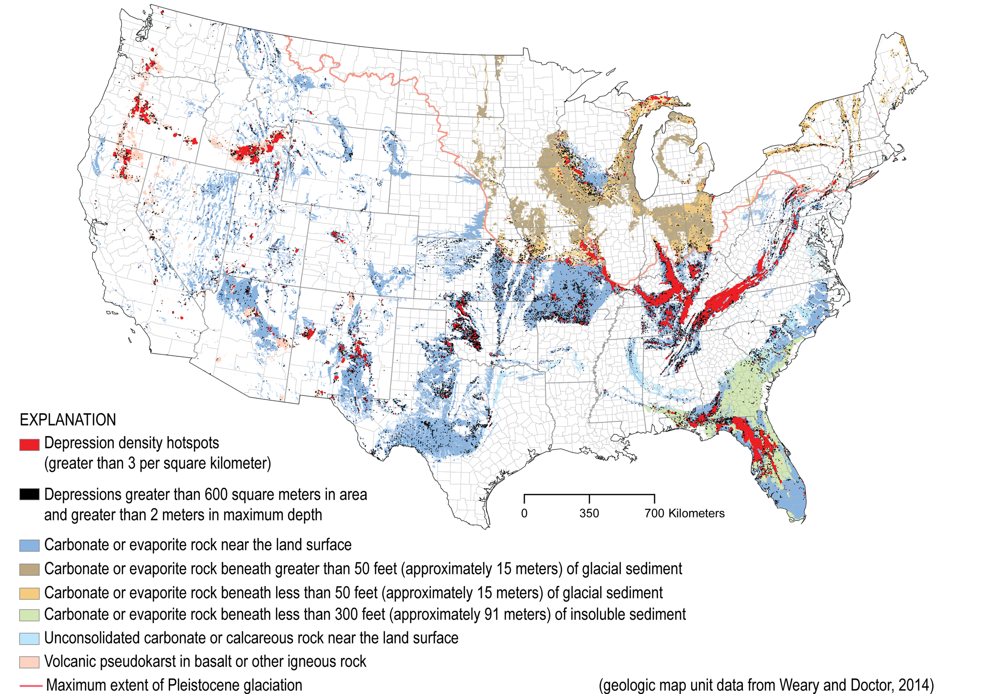

Source: USGS (2019),*[35]*.

Figure 3‑6. U.S. Karst Formations Map

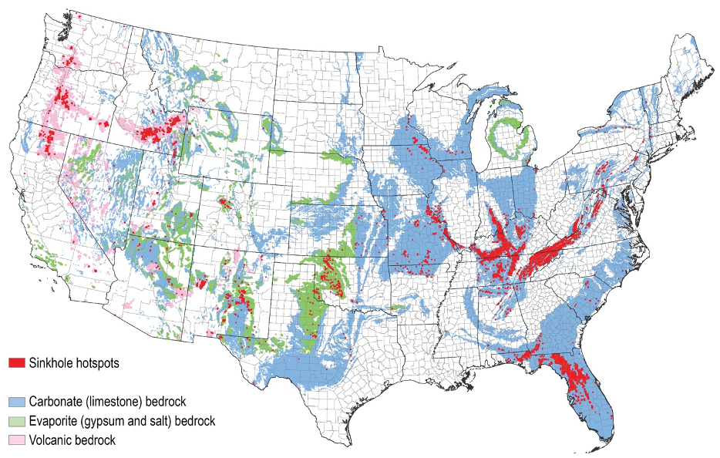

Source: USGS (2020),*[38]*.

## Effect of Subsidence on Pipelines

The information below was adopted from PRCI (2018) *[33]*. Although subsidence generally refers to a downward movement of the ground surface, lateral ground movement can also accompany subsidence. These movements can result in deformation of a pipeline that crosses the affected area and potentially lead to overstressing and failure of the pipeline. In many cases, the vertical movement is spread out over a large enough length of pipeline that the imposed bending stress is relatively minor, however the horizontal movement can drive a buried pipeline beyond its longitudinal (axial and bending) strain capacity.

## Subsidence Studies

The list of the relevant USGS subsidence studies for the different regions in U.S. is given below:

* Land Subsidence in the United States, USGS (1999), *[34]*
* Groundwater Depletion in The United States (1900−2008), Konikow (2013), *[26]*
* Landslide and Land Subsidence Hazards to Pipelines, Baum et al. (2008), *[4]*
* Analysis And Simulation of Regional Subsidence Accompanying Groundwater Abstraction and Compaction of Susceptible Aquifer Systems in the USA, Galloway and Sneed (2013), *[18]*
* Recent Geologic Hazard Studies at the Wink Sinkholes, BEG (2016), *[6]*
* Land Subsidence in California, USGS (2021a), *[36]*
* Texas Gulf Coast Groundwater and Land Subsidence, USGS (2021b), *[37]*
* List of Sinkholes, WikipediA (2025b) *[48]*.

# Expansive and Collapsible Soils

Expansive soils are those that swell or contract at constant applied loading following an increase or decrease in soil water content. Their swell or shrinkage potential derives from volume changes associated with the adsorption or release of water by the constituent clay minerals. In a natural environment, swelling and shrinking occur in response to cycles of wet and dry weather (rainfall and evaporation). Only the upper portion of the soil profile, described as the “active zone,” is affected by swelling or shrinking due to changes in water content. The depth of the active zone typically ranges from 5 to 15 ft (1.5 to 4.5 m) *[31]*. Pipelines buried within the active zone will cyclically move upward and downward following periods of soil wetting and drying. These displacements will induce stresses at locations where differential swell/shrinkage occurs, particularly at aboveground connections.

Collapsible soils cover significant areas around the world and are typically present in arid regions *[17]*. Collapsible soils are soils that are susceptible to large volumetric strains when they become saturated, meaning that the volume of the soil is greatly reduced when the soil is wetted *[12]*.

Soil collapse can take place upon wetting for a wide range of applied stress. As the applied stress is increased, the amount of collapse deformation experienced by an unsaturated soil reaches a maximum and then decreases to a negligible value. The maximum value attained depends on the soil type, density and moisture content. Larger collapse deformations are associated to low densities and low degrees of saturation *[1]*.

The existing methods for identifying collapsible soils generally rest on the following principles:

* Regional methods developed from empirical concepts and expedite tests, such as the methods based on consistency limits and physical indexes;
* Methods based on oedometer tests with wetting; and
* Methods based on field test, as the cone penetration test or specially designed plate load tests.

Buried pipelines can experience differential settlements transitioning in or out of areas where collapsible soils are present.

# Surface Fault Rupture

Geologic faults are earthquake- or gravity-induced discontinuities in the rock and soil profile. Earthquake-induced faults are present in seismically or formerly seismically active regions and may induce large (on the order of feet) displacements. Gravity-driven faults, (e.g., dip-slip faults in the soil record around the Gulf of Mexico), may induce only inches of displacement across the fault.

Tectonic faults are the most common type of active faults, and they are capable of large displacements over very short time periods. Growth faults are active faults that exhibit much slower rates of displacement, and yet, they can impose displacements beyond tolerable levels to pipelines, particularly when the pipeline is expected to remain in operation for a long period of time.

Active faults induce PGD and represent a significant geohazard for buried pipelines. Pipelines crossing fault zones must be allowed to deform longitudinally and in flexure to accommodate ground surface offsets *[30]*. The sketch on *Figure 5‑1* illustrates how fault displacements can subject buried pipes to a combination of bending and shear.

Many of the world’s most active faults have been studied *[49]* and interactive maps of faults are available online such as Quaternary faults in the U.S. shown in *Figure 5‑2* and seismogenic faults in Europe shown in *Figure 5‑3*. These faults are not necessarily active as defined above for pipeline design, and any such faults crossed by a pipeline will need to be further studied to evaluate if mitigation is required.

Figure 5‑1. Principal Modes of Soil-Pipeline Interaction at Fault Crossings

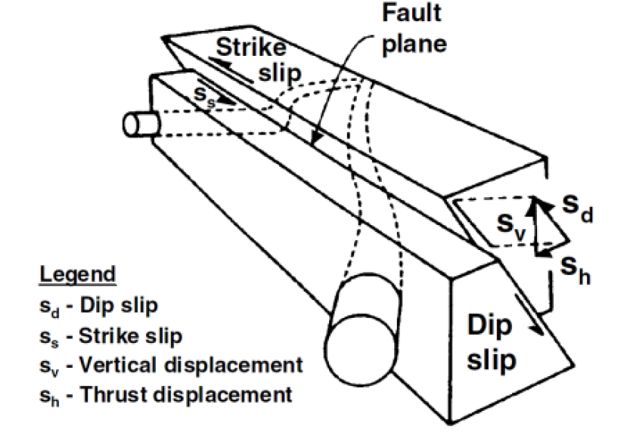

Source: O’Rourke (1998), *[32]*.

Figure 5‑2. U.S. Quaternary Faults Map

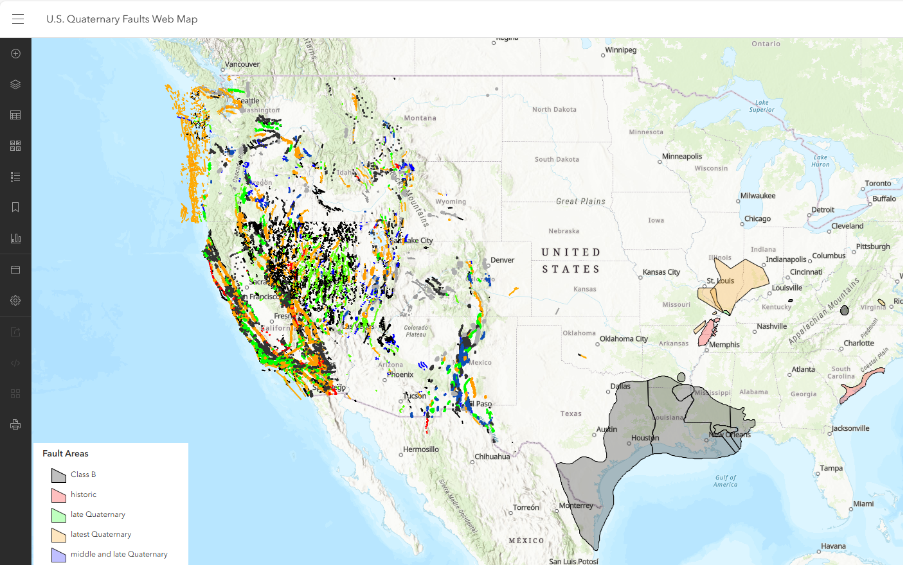

Source: USGS (2025b), *[41]*.

Figure 5‑3. Seismogenic faults - European Fault-Source Model 2020

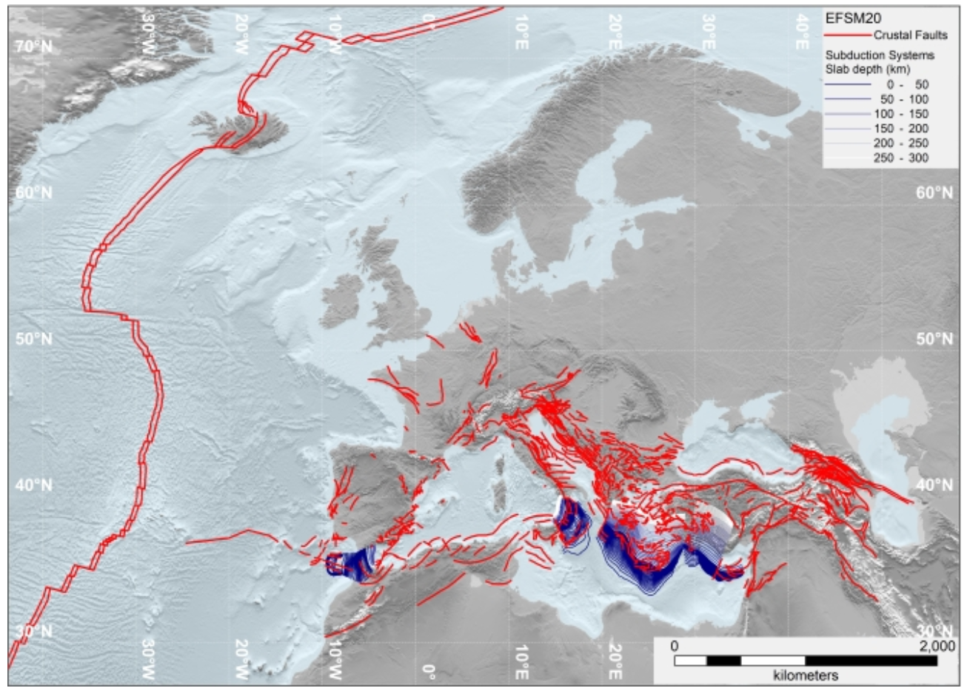

Source: Basili et al. (2022), EFSM20 *[3]*.

# Earthquake Ground Motion

Ground motion is the movement of the earth's surface from earthquakes or explosions which produced by waves that are generated by sudden slip on a fault or sudden pressure at the explosive source and travel through the earth and along its surface. Earthquake is a term used to describe both sudden slip on a fault, and the resulting ground shaking and radiated seismic energy caused by the slip, or by volcanic or magmatic activity, or other sudden stress changes in the earth.

The USGS monitors and reports on earthquakes, assesses earthquake impacts and hazards, and conducts targeted research on the causes and effects of earthquakes. Maps of earthquake shaking hazards provide information essential to creating and updating the seismic design provisions of building codes and develop seismic hazard map. A seismic hazard map shows the relative hazards in different areas. The maps are made based on the current knowledge about:

* Past faults and earthquakes
* The behavior of seismic waves as they travel through different ground layers
* The near-surface site conditions at specific locations of interest.

The seismic hazard map from USGS for U.S. is given on *Figure 6‑1*. This hazard map is a simplified 2% in 50-year probability of exceedance map. Earthquake hazard map shows peak ground accelerations (PGA) having a 2% probability of being exceeded in 50 years, for a firm rock. The USGS models are based on seismicity and fault-slip rates and take into account the frequency of earthquakes of various magnitudes. Locally, the hazard may be greater than shown, because site geology may amplify ground motions. The European Seismic Hazard Map is given on *Figure 6‑2*, which shows PGA having a 10% probability of being exceeded in 50 years.

An event that exceeds a ground shaking threshold of 10% or 2% in 50 years is often referred to as having a “return period” of 475 or 2,475 years. The seismic hazard maps for Germany, UK, Canada, Australia, New Zealand, Indonesia, Papua New Guinea (PNG) and Guyana are shown on *Figure 6‑3* through *Figure 6‑11.*

Figure 6‑1. U.S. Seismic Hazard Maps

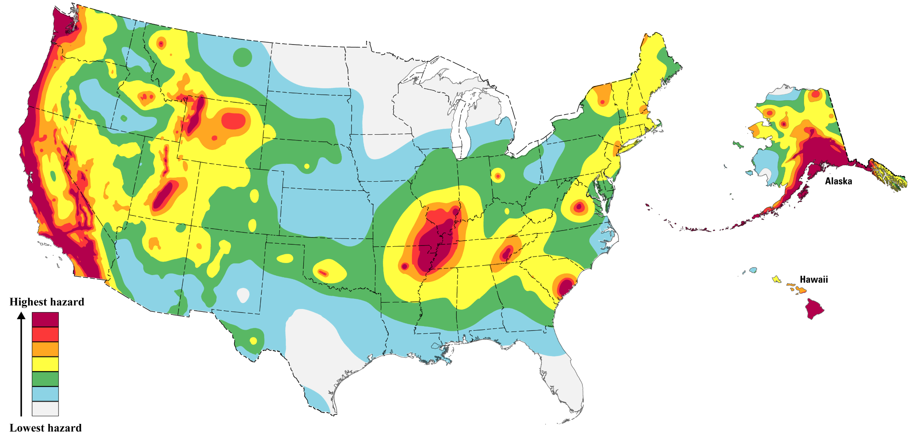

Source: USGS (2023), *[39]*. PGA 2% Exceedance Probability in 50 years.

Figure 6‑2. European Seismic Hazard Map

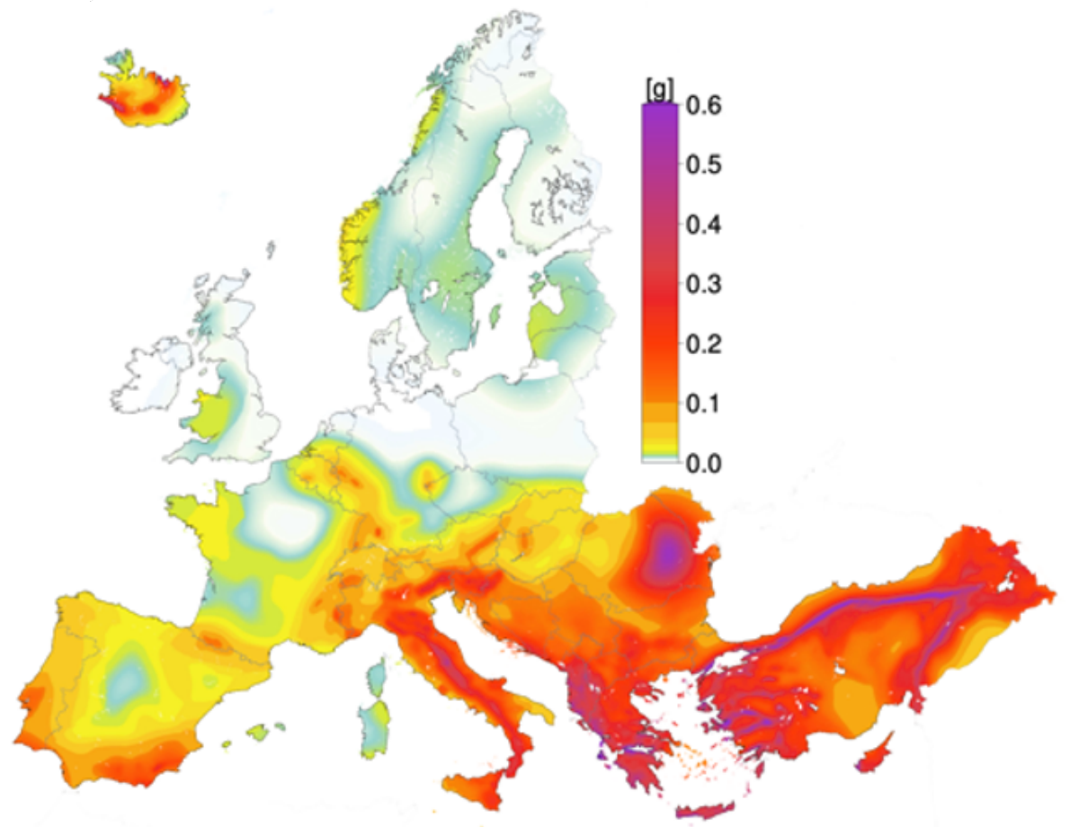

Source: Danciu (2024), *[11]*. PGA 10% Exceedance Probability in 50 years.

|  |  |
| --- | --- |
| Figure 6‑3. Germany Seismic Hazard Map | Figure 6‑4. UK Seismic Hazard Map |

Source: GEM (2021), *[19]*. PGA 10% Exceedance Probability in 50 years.

Figure 6‑5. Canada Seismic Hazard Map

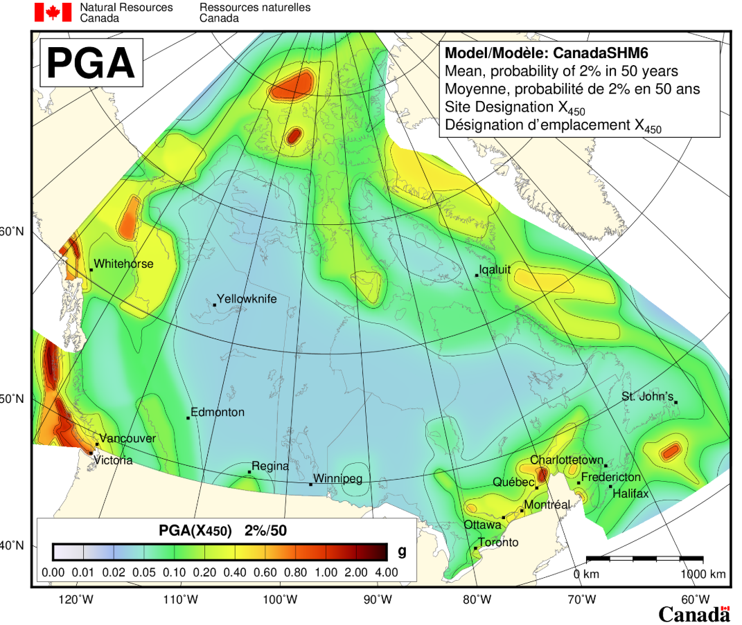

Source: NRC (2020), *[28]*. PGA 2% Exceedance Probability in 50 years.

Figure 6‑6. Australia Seismic Hazard Map

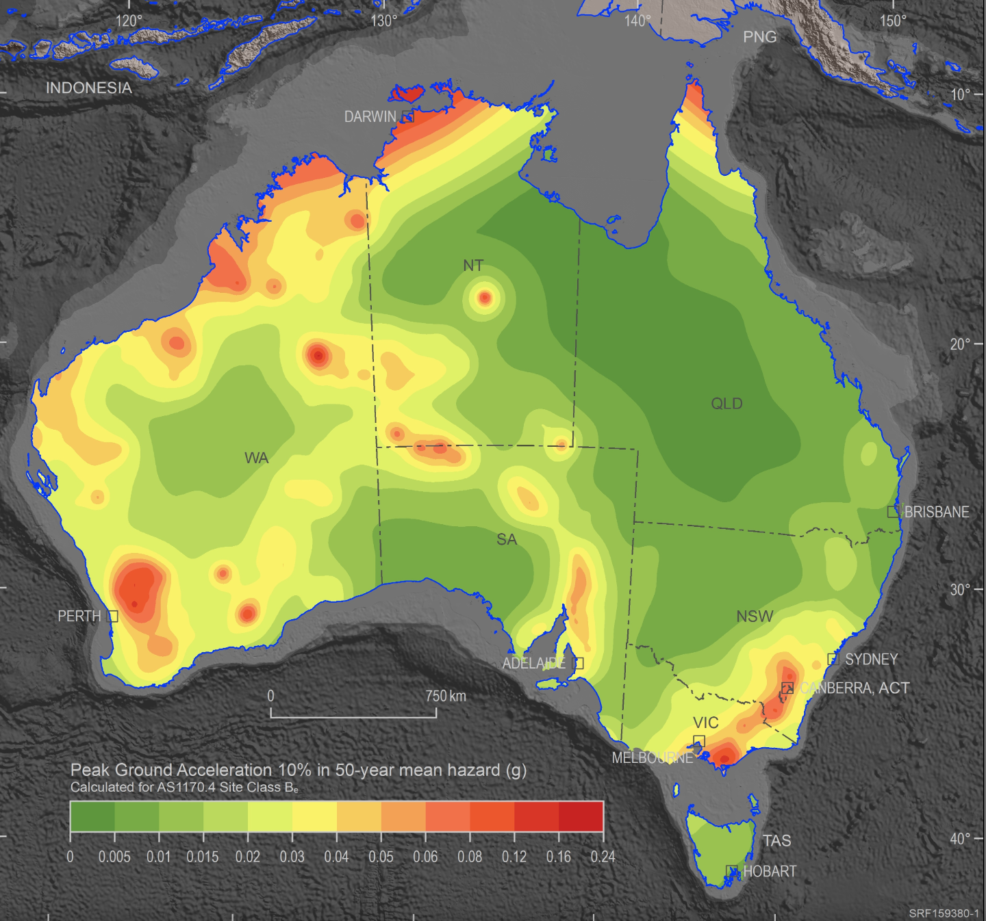

Source: Geoscience Australia (2023), *[21]*. PGA 10% Exceedance Probability in 50 years.

Figure 6‑7. New Zealand Seismic Hazard Map

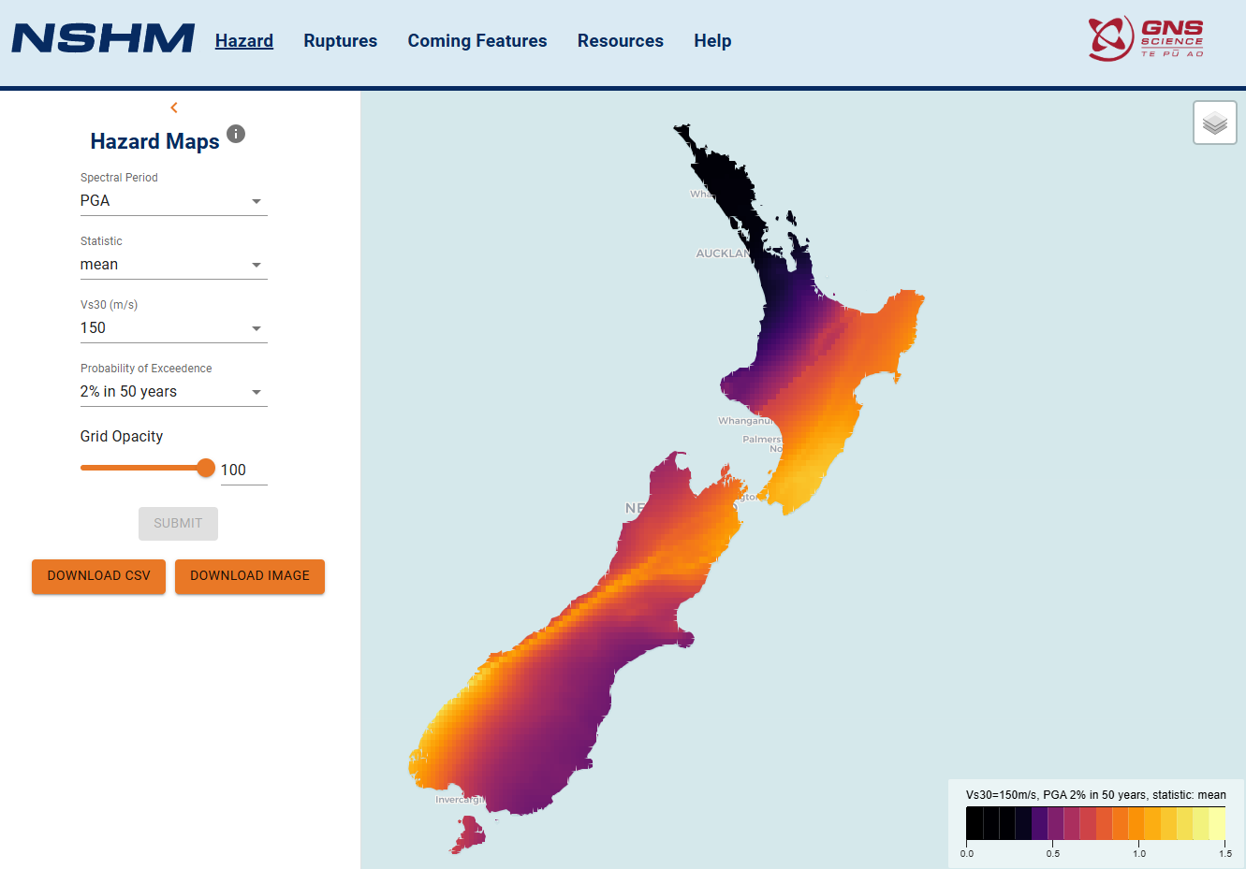

Source: NSHM (2025), *[27]*. PGA 2% Exceedance Probability in 50 years.

|  |  |
| --- | --- |
| Figure 6‑8. Indonesia Seismic Hazard Map    Figure 6‑9. New Zealand Seismic Hazard Map | Figure 6‑10. PNG Seismic Hazard Map    Figure 6‑11. Guyana Seismic Hazard Map |

Source: GEM (2021), *[19]*. PGA 10% Exceedance Probability in 50 years.

Earthquake data are available through the publicly available resources summarized in *Table 6‑1*.

The severity of an earthquake can be expressed in terms of both intensity and magnitude. Magnitude is related to the amount of seismic energy released at the hypocenter of the earthquake. It is based on the amplitude of the earthquake waves recorded on instruments which have a common calibration. The magnitude of an earthquake is thus represented by a single, instrumentally determined value. The most commonly used is the Richter magnitude scale.

Intensity is based on the observed effects of ground shaking on people, buildings, and natural features. It varies from place to place within the disturbed region depending on the location of the observer with respect to the earthquake epicenter. Although numerous intensity scales have been developed to evaluate the effects of earthquakes, the one currently used in the United States is the Modified Mercalli Intensity (MMI) Scale. This scale, composed of 12 increasing levels of intensity that range from imperceptible shaking to catastrophic destruction, is designated by Roman numerals. It does not have a mathematical basis; instead, it is an arbitrary ranking based on observed effects.

Table 6‑1. Earthquake databases and relevant seismic products

|  |  |  |
| --- | --- | --- |
| **Country** | **Sources** | **Data Link** |
| U.S./World | USGS *[43]* | [*https://earthquake.usgs.gov/earthquakes/search/*](https://earthquake.usgs.gov/earthquakes/search/) |
| Canada | NRC *[29]* | [*https://earthquakescanada.nrcan.gc.ca/index-en.php*](https://earthquakescanada.nrcan.gc.ca/index-en.php) |
| UK | BGS *[7]* | [*https://quakes.bgs.ac.uk/earthquakes/home.html*](https://quakes.bgs.ac.uk/earthquakes/home.html) |
| Australia | Geoscience Australia *[22]* | [*https://earthquakes.ga.gov.au/*](https://earthquakes.ga.gov.au/) |
| Indonesia | BMKG *[8]* | [*https://inatews.bmkg.go.id/eng*](https://inatews.bmkg.go.id/eng) |
| New Zealand | GeoNet *[20]* | [*https://www.geonet.org.nz/earthquake*](https://www.geonet.org.nz/earthquake) |
| Europe/World | EMSC *[14]* | [*http://www.emsc-csem.org*](http://www.emsc-csem.org/) |

Based on USGS a level I-V on the MMI scale would represent a small amount of observable damage. At this level doors would rattle, dishes break and weak or poor plaster would crack. A damaging earthquake shaking is considered as MMI level VI or higher. Earthquake magnitude versus intensity conversion is shown in *Table 6‑2*.

Table 6‑2. Earthquake Magnitude/Intensity Comparison

|  |  |  |  |
| --- | --- | --- | --- |
| **Estimated Magnitude** | **MMI - Shaking** | **PGA (g)** | **Description/Damage** |
| 1.0 – 3.0 | **I – Not Felt** | <0.001 | Not felt except by very few under especially favorable conditions. |
| 3.0 – 3.9 | **II – Weak** | 0.001-0.002 | Felt only by a few people at rest, especially on upper floors of buildings. Delicately suspended objects may swing. |
| 3.0 – 3.9 | **III – Weak** | 0.002-0.005 | Felt quite noticeably by people indoors, especially on upper floors of buildings: Many people do not recognize it as an earthquake. Standing vehicles may rock slightly. Vibrations are similar to the passing of a truck, with duration estimated |
| 4.0 – 4.9 | **IV – Light** | 0.005-0.01 | Felt indoors by many, outdoors by few during the day: At night, some are awakened. Dishes, windows, and doors are disturbed; walls make cracking sounds. Sensations are like a heavy truck striking a building. Standing vehicles are rocked noticeably. |
| 4.0 – 4.9 | **V – Moderate** | 0.01-0.025 | Felt by nearly everyone; many awakened: Some dishes and windows are broken. Unstable objects are overturned. |
| 5.0 – 5.9 | **VI – Strong** | 0.025-0.051 | Felt by all, and many are frightened. Some heavy furniture is moved; a few instances of fallen plaster occur. Damage is slight. |
| 5.0 – 7.0+ | **VII – Very Strong** | 0.051-0.102 | Damage is negligible in buildings of good design and construction; but slight to moderate in well-built ordinary structures; damage is considerable in poorly built or badly designed structures; some chimneys are broken. |
| 6.0 – 7.0+ | **VIII – Severe** | 0.102-0.255 | Damage slight in specially designed structures; considerable damage in ordinary substantial buildings with partial collapse. Damage great in poorly built structures. Fall of chimneys, factory stacks, columns, monuments, walls. Heavy furniture overturned. Sand and mud ejected in small amounts. Changes in well water. |
| 6.0 – 7.0+ | **IX – Violent** | 0.255-0.510 | Damage is considerable in specially designed structures; well-designed frame structures are thrown off-kilter. Damage is great in substantial buildings, with partial collapse. Buildings are shifted off foundations. Liquefaction occurs. Underground pipes are broken. |
| 7.0+ | **X – Extreme** | > 0.510g | Some well-built wooden structures are destroyed; most masonry and frame structures are destroyed with foundations. Rails are bent. Landslides considerable from riverbanks and steep slopes. Shifted sand and mud. Water splashed over riverbanks.  Few, if any, (masonry) structures remain standing. Bridges are destroyed. Broad fissures erupt in the ground. Underground pipelines are rendered completely out of service. Earth slumps and land slips in soft ground. Rails are bent greatly.  Damage is total. Waves are seen on ground surfaces. Lines of sight and level are distorted. Objects are thrown upward into the air. |

Source: USGS (2025c) *[42]*.

# Soil Liquefaction

In regions of high seismic activity, soil liquefaction has been identified as a major hazard to pipeline structures. Soil liquefaction (or simply liquefaction) is a term used to describe the temporary reduction of the shear strength of soil that is typically caused by seismically induced ground motions. Liquefaction has been defined as "the transformation of a cohesionless material from a solid state into a liquefied state as a consequence of increased pore pressure and reduced effective stress”. Liquefaction also reduces the volume of the soil, and this reduction may manifest as vertical settlement *Figure 7‑1* . Conditions most conducive to liquefaction involve developing:

* Presence of susceptible soils such as coarse-grained materials in a relatively loose state
* Shallow groundwater table & soil saturation
* Sufficiently large ground motions (typically from an earthquake but may also be caused by construction equipment or blasting operations) common for seismically active regions.

Figure 7‑1. Liquefaction Process and Impact on Buried Pipelines

|  |  |
| --- | --- |
|  |  |

Source: Adopted from Engineering Geology *[15]* and USGS (2025e) *[44]*.

Liquefaction susceptibility maps are available from public sources covering different geographical regions, such as California, Illinois, Mississippi in USA *[45]*, *[10]*, British Columbia in Canada *[5]*, New Zealand *[13]*.

# Lateral Spreading

Lateral spreading is one of the most common forms of ground deformation associated with liquefaction during earthquakes. Lateral spreading in the liquefied ground often causes several feet of differential large ground displacements. This deformation mode involves lateral extension of intact surficial material caused by liquefaction of a subjacent layer. The displacements can range from a few to several feet and normally occur in very gentle slopes that are thought to be stable otherwise. The surficial material, being carried along as the underlying liquefied mass, can impose a significant load on the pipeline. Pipelines that cross these areas of differential displacement may be deformed inelastically or might be buckled or ruptured.

Figure 8‑1. Lateral Spreading

|  |  |
| --- | --- |
|  |  |

Source: USGS (2025e) *[44]*.

# Frost Heave and Thaw

Frost heave is the process by which the ground swells due to the expansion of water as the water freezes. Frost heave occurs in regions where groundwater is susceptible to both freezing and thawing, see *Figure 9‑1*.

Frost heave of soils varies greatly with the type of soil and the moisture and thermal conditions of the ground. These variations can cause the initially level trench-bottom profile of a pipeline to become uneven. Upheaval buckling can lead to large upward movements of a pipeline and is caused by the interaction between the longitudinal compressive force present during operation and overbend irregularities in the profile.

Figure 9‑1. Schematics of Frost Heave and Thaw Settlement for Buried Pipeline

|  |  |
| --- | --- |
| Frost Heave | Thaw Settlement |

Acronyms and Abbreviations

BEG Texas Bureau of Economic Geology

BGS British Geological Survey

BMKG Badan Meteorologi, Klimatologi, dan Geofisika

EMPS ExxonMobil Product Solutions

EMSC Euro-Mediterranean Seismological Centre Portal

EMTech ExxonMobil Technology and Engineering

FEMA Federal Emergency Management Agency

GEM Global Earthquake Model

GMP Geohazard Management Program

MMI Modified Mercalli Intensity Scale

NRC Natural Resources Canada

NSHA National Seismic Hazard Assessment

NSHM New Zealand National Seismic Hazard Model

PGA Peak Ground Acceleration

PGD Permanent Ground Deformation

PNG Papua New Guinea

PRCI Pipeline Research Council International

UK United Kingdom

US or USA United States of America

USGS United States Geological Survey

WCP Water Crossing Program

XOM ExxonMobil Corporation

External References

*[1]* Alonso, E.E., Gens, A. & Josa, A. (1990). A constitutive model for partially saturated soil, Géotechnique, 40(3): pp. 405-430.

*[2]* ARUP (2020). The Global Landslide Hazard Map. The World Bank, Final Project Report, 26 June 2020. Prepared by Ove Arup & Partners International Ltd. 113p. Available online at: [*https://datacatalog.worldbank.org/search/dataset/0037584*](https://datacatalog.worldbank.org/search/dataset/0037584)*.* Accessed March 2025.

*[3]* Basili R., Danciu L., Beauval C., Sesetyan K., Vilanova S., Adamia S., Arroucau P., Atanackov J., Baize S., Canora C., Caputo R., Carafa M., Cushing M., Custódio S., Demircioglu Tumsa M., Duarte J., Ganas A., García-Mayordomo J., Gómez de la Peña L., Gràcia E., Jamšek Rupnik P., Jomard H., Kastelic V., Maesano F. E., Martín-Banda R., Martínez-Loriente S., Neres M., Perea H., Sket-Motnikar B., Tiberti M. M., Tsereteli N., Tsironi V., Vallone R., Vanneste K., Zupančič P. (2022). European Fault-Source Model 2020 (EFSM20): Online data on fault geometry and activity parameters [Data set]. Istituto Nazionale di Geofisica e Vulcanologia (INGV). <https://doi.org/10.13127/efsm20> Accessed March 2025.

*[4]* Baum, R.L., Galloway, D.L and Harp E.L. (2008). Landslide and Land Subsidence Hazards to Pipelines. United States Geological Survey Open File Report, 2008-1164, prepared in cooperation with U.S. Dept. of Transportation, Pipeline Research Council International, and DGH Consulting Inc. Available online at: [*https://pubs.er.usgs.gov/publication/ofr20081164*](https://pubs.er.usgs.gov/publication/ofr20081164). Accessed March 2025.

*[5]* British Columbia Geological Survey (2025). Natural hazards geoscience resources. Available online at: [*https://www2.gov.bc.ca/gov/content/industry/mineral-exploration-mining/british-columbia-geological-survey/geology/natural-hazards-geoscience*](https://www2.gov.bc.ca/gov/content/industry/mineral-exploration-mining/british-columbia-geological-survey/geology/natural-hazards-geoscience) . Accessed March 2025.

*[6]* BEG (2016). Recent Geologic Hazard Studies at the Wink Sinkholes. Texas Bureau of Economic Geology (BEG). Available online at: [*http://www.beg.utexas.edu/node/1413*. Accessed March 2025](http://www.beg.utexas.edu/node/1413.%20Accessed%20March%202025).

*[7]* BGS (2025). British Geological Survey. Earthquakes. Available online at: <https://quakes.bgs.ac.uk/earthquakes/home.html>.Accessed March 2025.

*[8]* BMKG (2025). Indonesia Tsunami Early Warning System. Badan Meteorologi, Klimatologi, dan Geofisika. Available online at: [*https://inatews.bmkg.go.id/eng*](https://inatews.bmkg.go.id/eng)*.* Accessed March 2025.

*[9]* Bobrowsky, P T; and Dominguez, M J. (2012). Landslide susceptibility map of Canada. Geological Survey of Canada. Open File 7228, 2012, 1 sheet, Available online at: [*https://doi.org/10.4095/291902*. Accessed March 2025](https://doi.org/10.4095/291902.%20Accessed%20March%202025).

*[10]* CUSEC (1999). Soil Amplification/Liquefication Potential Map. Association of Central United States Earthquake Consortium (CUSEC) Stage Geologists and USGS. Published in 1999. Available online at: [*https://cusec.org/publications/maps/cusecsgmap.pdf*](https://cusec.org/publications/maps/cusecsgmap.pdf)*.* Accessed March 2025.

*[11]* Danciu, L., Giardini, D., Weatherill, G., Basili, R., Nandan, S., Rovida, A., Beauval, C., Bard, P.-Y., Pagani, M., Reyes, C. G., Sesetyan, K., Vilanova, S., Cotton, F., and Wiemer, S.: The 2020 European Seismic Hazard Model: overview and results, Nat. Hazards Earth Syst. Sci., 24, 3049–3073, *https://doi.org/10.5194/nhess-24-3049-2024*, 2024. Accessed March 2025.

*[12]* Dudley, J.H. (1970). Review of collapsing soils. Journal of the Soil Mechanics and Foundation Division, 96(3):925-947.

*[13]* ECRC (2025). Liquefaction susceptibility map for Waitaha/Canterbury. Environment Canterbury Regional Council. Available online at: [*https://www.ecan.govt.nz/your-region/your-environment/natural-hazards/earthquakes/liquefaction*](https://www.ecan.govt.nz/your-region/your-environment/natural-hazards/earthquakes/liquefaction)*.* Accessed March 2025.

*[14]* EMSC (2025). Euro-Mediterranean Seismological Centre Portal. Available online at: [*http://www.emsc-csem.org/*](http://www.emsc-csem.org/). Accessed March 2025.

*[15]* Engineering Geology (2025). MiMaEd Website. Available online at: [[*https://mimaed.com/what-is-liquefaction/*](https://mimaed.com/what-is-liquefaction/)*/*](http://www.emsc-csem.org/). Accessed March 2025.

*[16]* FEMA (2025). Federal Emergency Management Agency (FEMA), 2025. Basic Terminology/ Natural Hazards. Available online at: <https://emilms.fema.gov/is_0559/groups/108.html> & <https://hazards.fema.gov/nri/natural-hazards>. Accessed March 2025.

*[17]* Gaaver, K.E. (2012). Geotechnical properties of Egyptian collapsible soils. Alexandria Engineering Journal 51(3): 205–210.

*[18]* Galloway, D.L., Sneed, M. (2013). Analysis and simulation of regional subsidence accompanying groundwater abstraction and compaction of susceptible aquifer systems in the USA. Boletín de la Sociedad Geológica Mexicana, Volume 65, no. 1, 2013, p. 123-136.

*[19]* GEM (2021). Global Earthquake Model. Global Earthquake Hazard and Risk Models. Available online <https://github.com/gem>. Accessed March 2025.

*[20]* GeoNet (2025). GeoNet project portal. Available online at: <https://www.geonet.org.nz/earthquake>. Accessed March 2025.

*[21]* Geoscience Australia (2023). National Seismic Hazard Assessment (NSHA) NSHA23 hazard map. Mean PGA 10% in 50 year seismic hazard map. Geoscience Australia, Canberra. Available online at: <https://www.ga.gov.au/scientific-topics/community-safety/projects/nsha>. Accessed March 2025.

*[22]* Geoscience Australia (2025). Earthquakes@GA Dashboard. Geoscience Australia, Canberra. <https://earthquakes.ga.gov.au/>. Accessed March 2025.

*[23]* Herrera-García G., Ezquerro P., Tomás R., Béjar-Pizarro M., López-Vinielles J., Rossi M., Mateos R. M., Carreón-Freyre D., Lambert J., Teatini P., Cabral-Cano E., Erkens G., Galloway D., Hung W.C., Kakar N., Sneed M., Tosi L., Wang H., Ye S. (2021). Mapping the global threat of land subsidence. Science Vol. 371, Issue 6524, pp. 34-36. Published by American Association for the Advancement of Science. <https://doi.org/10.1126/science.abb8549>.

*[24]* Highland, L.M., and P. Bobrowsky (2008). The Landslide Handbook – A Guide to Understanding Landslide. Reston, VA, United States Geological Survey Circular 1325, 129 p.

*[25]* Kim J-W, Zhong L., Degrandpre K. (2016). Ongoing Deformation of Sinkholes in Wink, Texas, Observed by Time-Series Sentinel-1A SAR Interferometry (Preliminary Results). Remote Sensing Journal, 2016, 8 (4), 313.

*[26]* Konikow, L.F. (2013). Groundwater depletion in the United States (1900−2008): U.S. Geological Survey Scientific Investigations Report 2013−5079, 63 p., <http://pubs.usgs.gov/sir/2013/5079>.

*[27]* NSHM (2025). New Zealand National Seismic Hazard Model, version NSHM_v1.0.4. GNS Science. Available online at: [*https://nshm.gns.cri.nz/HazardMaps*](https://nshm.gns.cri.nz/HazardMaps). Accessed March 2025.

*[28]* NRC (2020). 2020 National Building Code of Canada seismic hazard maps, Natural Resources Canada Available online at: <https://www.earthquakescanada.nrcan.gc.ca/hazard-alea/zoning-zonage/NBCC2020maps-en.php>. Accessed March 2025.

*[29]* NRC (2025). Natural Resources Canada. Earthquakes Canada. Available online at: [*https://www.earthquakescanada.nrcan.gc.ca/index-en.php*](https://www.earthquakescanada.nrcan.gc.ca/index-en.php). Accessed March 2025.

*[30]* Nyman, D.J., E.M. Lee, and J.M.E. Audibert (2008). Mitigating Geohazards for International Pipe-line Projects: Challenges and Lessons Learned. Proceedings of 7th International Pipeline Conference (IPC), 2008, Paper IPC2008-64405.

*[31]* O’Neill, M., and N. Poormoayed. (1980). Methodology for Foundations on Expansive Clays. Journal of the Geotechnical Division 106 (GT12):1345–1367.

*[32]* O’Rourke, T.D. (1998). An Overview of Geotechnical and Lifeline Earthquake Engineering. Proceedings of Geotechnical Earthquake Engineering and Soil Dynamics Conference Geotechnical Special Publication No. 75, ASCE. Vol. 2, 1392–1426.

*[33]* PRCI (2018). Guidelines for Management of Geohazards Affecting the Engineering and Construction of New Oil and Natural Gas Pipelines. PR-616-164506. May 2018.

*[34]* USGS (1999). Land subsidence in the United States, edited by Galloway D., Jones D. R. and Ingebritsen S.E., USGS Circular 1182, 177p. Available online at: [*https://pubs.usgs.gov/circ/circ1182/*](https://pubs.usgs.gov/circ/circ1182/)*.* Accessed March 2025.

*[35]* USGS (2019). Subsidence Susceptibility Map for the Conterminous U.S. Available online at: <https://www.usgs.gov/centers/community-for-data-integration-cdi/science/subsidence-susceptibility-map-conterminous-us#overview> from <https://www.sciencebase.gov/catalog/item/5cd2ea33e4b09b8c0b7a5c59> Accessed March 2025.

*[36]* USGS (2021a). Land Subsidence in California. <https://www.usgs.gov/centers/ca-water-ls>. Accessed in March 2025.

*[37]* USGS (2021b). Texas Gulf Coast Groundwater and Land Subsidence Program. [https://www.usgs.gov/centers/ot-water/science/texas-gulf-coast-groundwater-and-land-subsidence-program?qt-science_center_objects=0 - qt-science_center_objects](https://www.usgs.gov/centers/ot-water/science/texas-gulf-coast-groundwater-and-land-subsidence-program?qt-science_center_objects=0%20-%20qt-science_center_objects). Accessed in March 2025.

*[38]* USGS (2020). Karst Map of the Conterminous United States - 2020. Available online at: [*https://www.usgs.gov/media/images/karst-map-conterminous-united-states-2020*](https://www.usgs.gov/media/images/karst-map-conterminous-united-states-2020) from [*https://doi.org/10.5038/9781733375313.1003*](https://doi.org/10.5038/9781733375313.1003)*.* Accessed March 2025.

*[39]* USGS (2023). Hazard map from the 2023 50-state update of the National Seismic Hazard Model Project. Available online at: <https://www.usgs.gov/media/images/hazard-map-2023-50-state-update-national-seismic-hazard-model-project>. Accessed March 2025.

*[40]* USGS (2025a). U.S. Landslide Inventory and Susceptibility. USGS Landslide Hazard Program. Available online at: <https://www.arcgis.com/apps/webappviewer/index.html?id=ae120962f459434b8c904b456c82669d>. Accessed March 2025.

*[41]* USGS (2025b). U.S. Geological Survey. US Quaternary faults. Available online at: <https://usgs.maps.arcgis.com/apps/webappviewer/index.html?id=5a6038b3a1684561a9b0aadf88412fcf>. Accessed March 2025.

*[42]* USGS (2025c). Modified Mercalli Intensity Scale, Available online at: [hthttps://www.usgs.gov/programs/earthquake-hazards/modified-mercalli-intensity-scale](https://www.usgs.gov/programs/earthquake-hazards/modified-mercalli-intensity-scale). Accessed March 2025.

*[43]* USGS (2025d). Earthquake Hazards Program. Earthquake Catalog. Available online at: <https://earthquake.usgs.gov/earthquakes/search/>. Accessed March 2025.

*[44]* USGS (2025e). Natural Hazards. Available online at: <https://www.usgs.gov/faqs/what-liquefaction> and <https://www.usgs.gov/media/images/lateral-spread>. Accessed March 2025.

*[45]* USGS (2025f). Liquefaction Susceptibility. Available online at: [*https://earthquake.usgs.gov/education/geologicmaps/liquefaction.php*](https://earthquake.usgs.gov/education/geologicmaps/liquefaction.php). and <https://www.usgs.gov/media/images/liquefaction-susceptibility-map-san-franciscooakland-area> Accessed March 2025.

*[46]* Varnes, D. J. (1978). Slope Movement Types and Processes. In Special Report 176: Landslides: Analysis and Control, Transportation and Road Research Board, National Academy of Science, Washington D.C. 11-33

*[47]* WikipediA (2025a). Subsidence. <https://en.wikipedia.org/wiki/Subsidence>. Accessed March 2025.

*[48]* WikipediA (2021b). List of sinkholes. <https://en.wikipedia.org/wiki/List_of_sinkholes>. Accessed March 2025.

*[49]* Yeates, R. (2012). Active Faults of the World. Cambridge University Press. 621 pp.